**-NAME:** Savan Yeshwanth Rao

**CSUID:** 2784780

**Course:** EEC-584 Computer Networks

**LAB-1 HTTP REPORT**

1. **The Basic HTTP GET/response interaction message:**

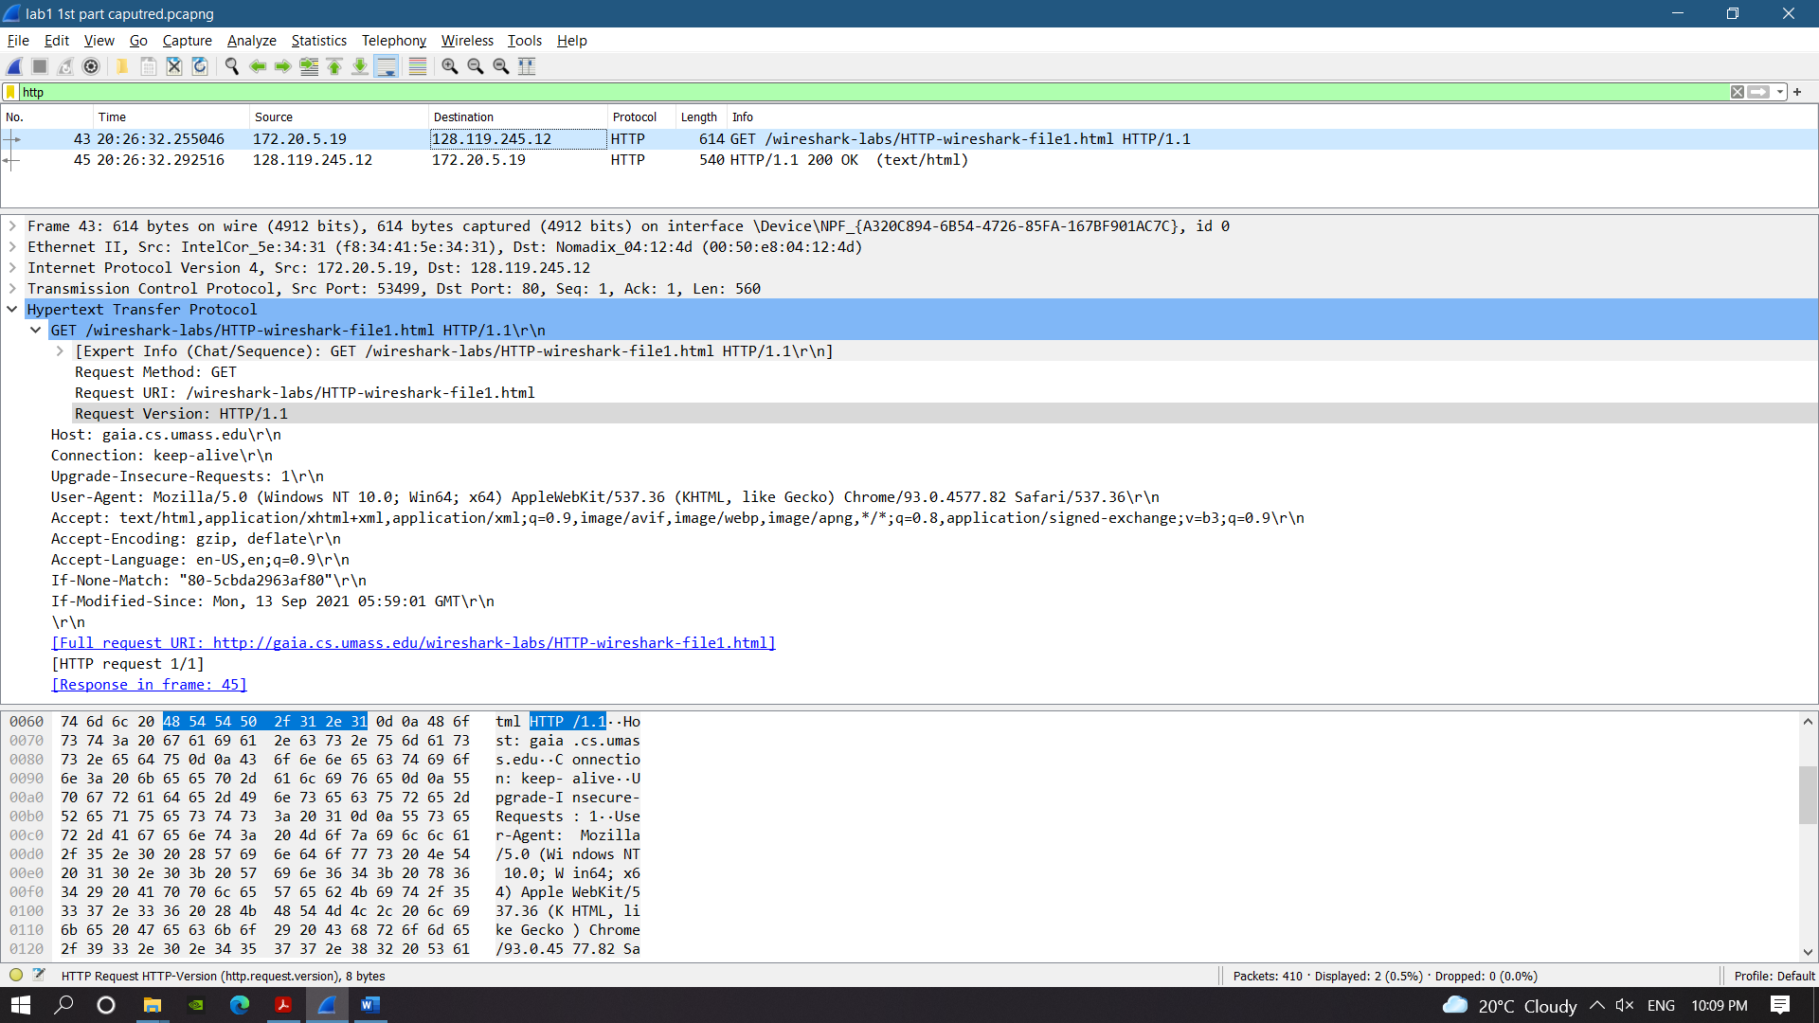

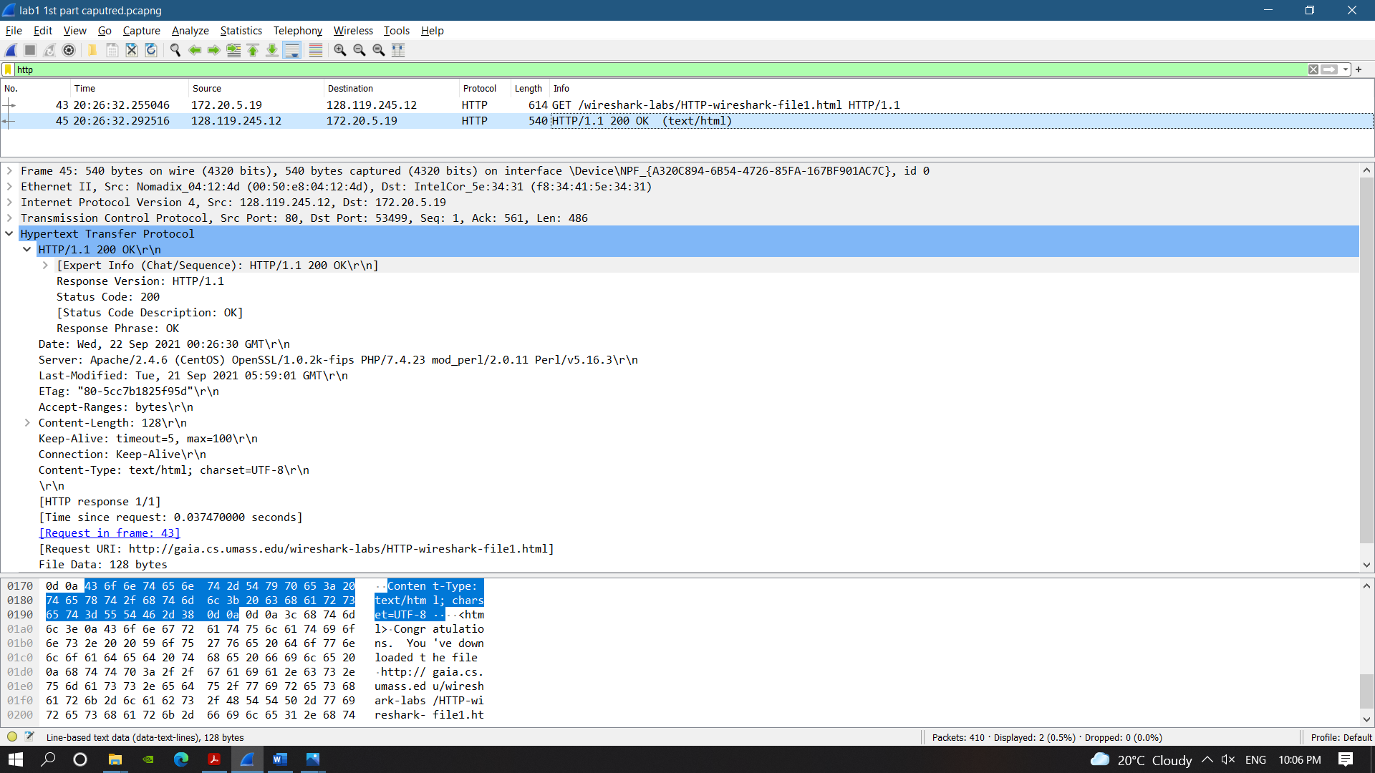

1. HTTP version running in my browser– **HTTP 1.1**

HTTP version running by Server- **HTTP 1.1**

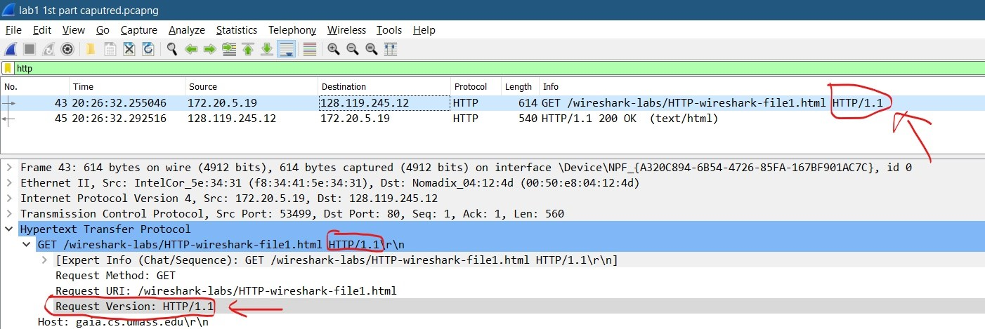

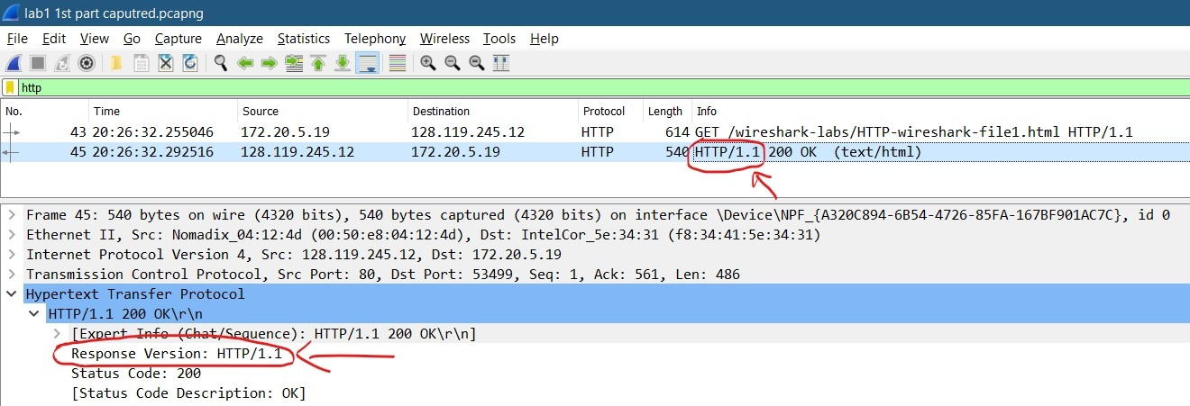

1. Language accepted: **en-US (English-US), en (English).**

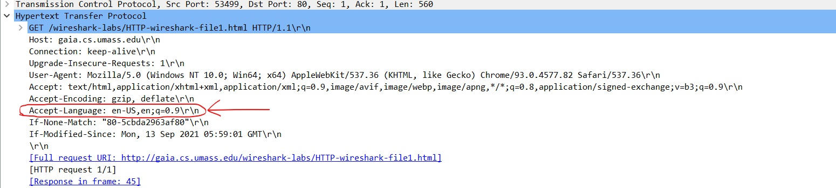

1. IP address of my computer- **172.20.5.19**

IP address of gaia.cs.umass.edu server- **128.119.245.12**

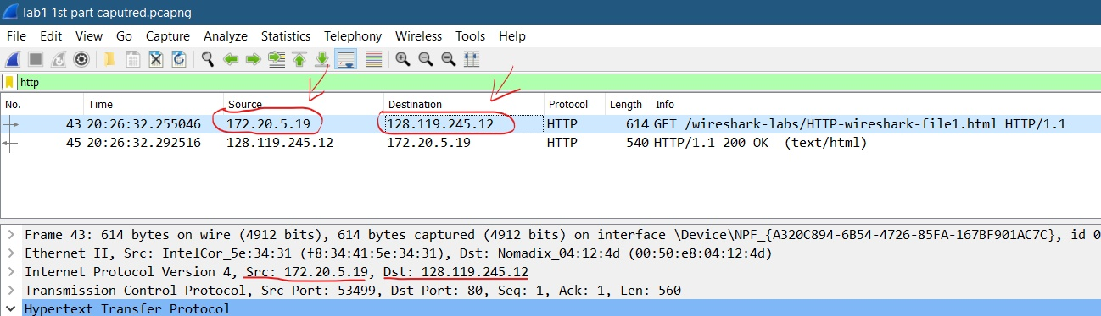

1. Status returned from server- **200 OK**

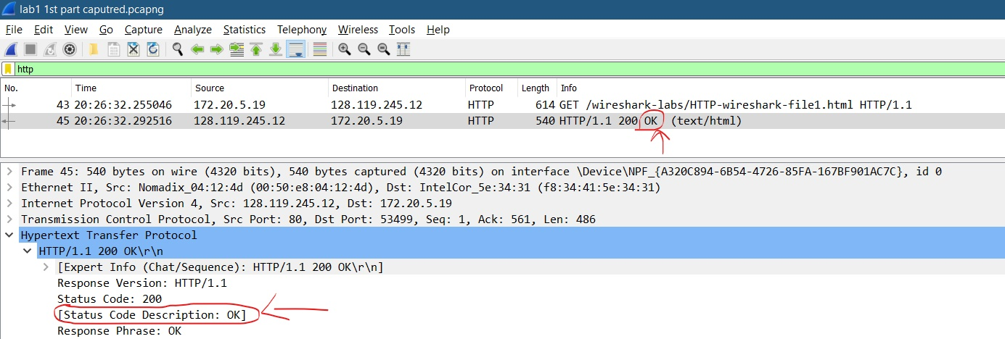

1. Last Modified- **Tue, 21 Sep 2021 05:59:01 GMT.**

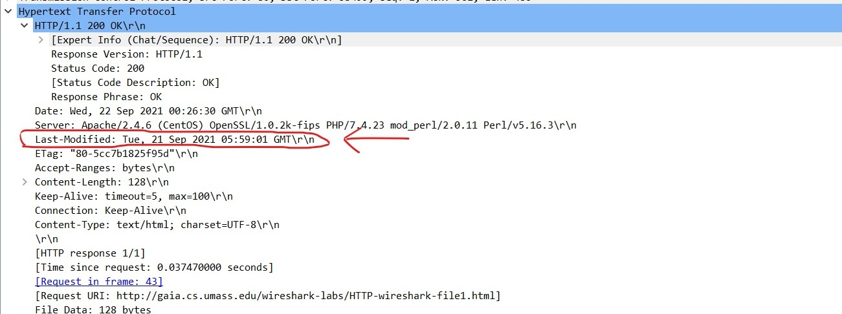

1. Content being returned- **128 bytes.**

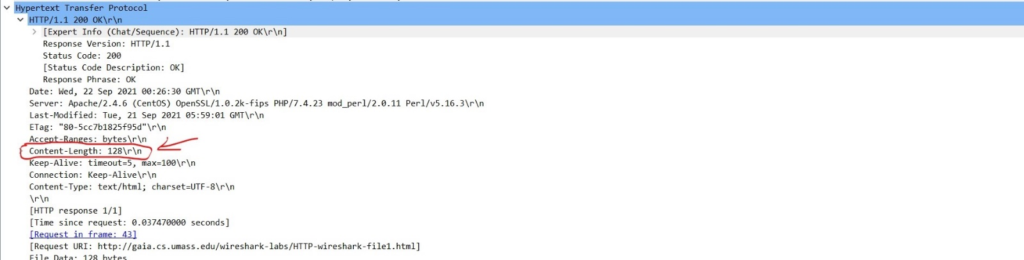

1. **NO,** there no other headers within the data that are not displayed in packet-listing window. Even the line-based data text data is present along with all other datagrams. As all the headers are present in the raw data. And we know that HTTP message was carried inside a TCP segment, which was carried inside an IP datagram, which was carried within an Ethernet frame, Wireshark displays the Frame, Ethernet, IP, and TCP packet information.

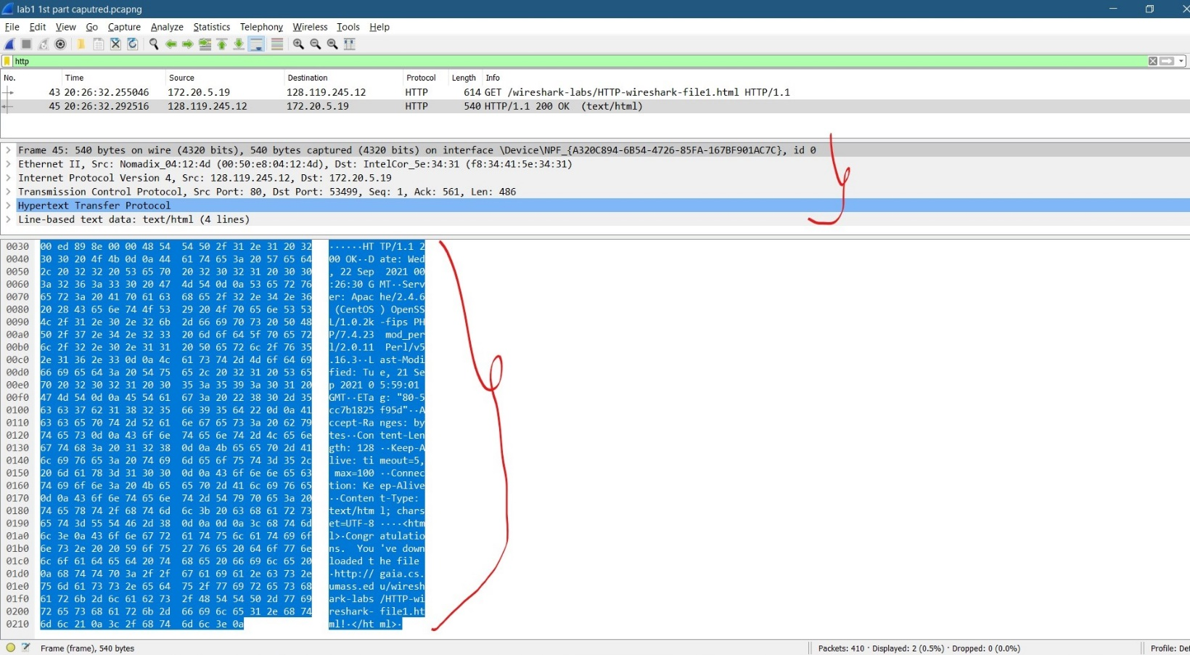

1. **The HTTP CONDITIONAL Get/ response interaction:**
2. **No,** there is no “IF-MODIFIED-SINCE” line in the first HTTP GET request.

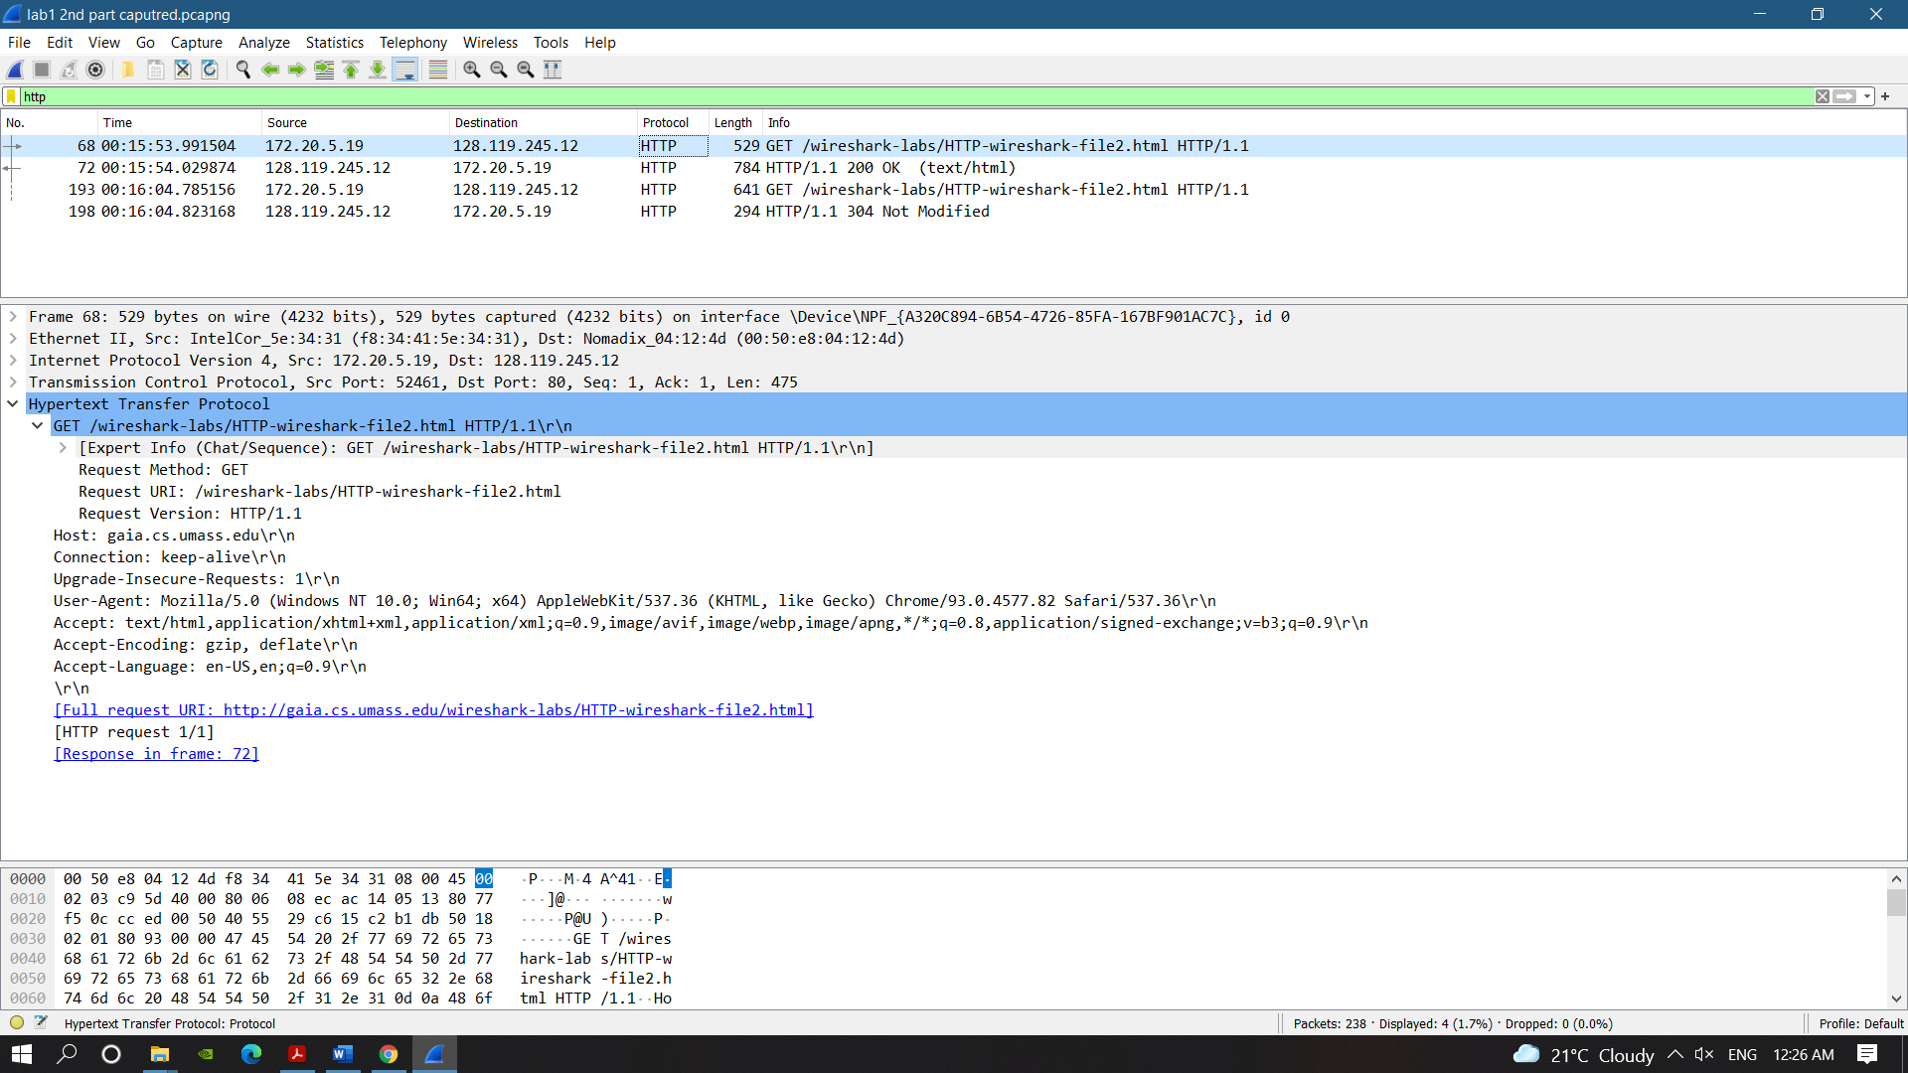

1. **Yes,** the Server did explicitly return the contents of the file. As we can see from the image bellow the Response to first HTTP GET there is a “**Content-length”** field i.e., Content length= 371 bytes and also a “**Line based text data”** header with the actually data been displayed in the Packet header detail window as well as in the raw data in packet content window.

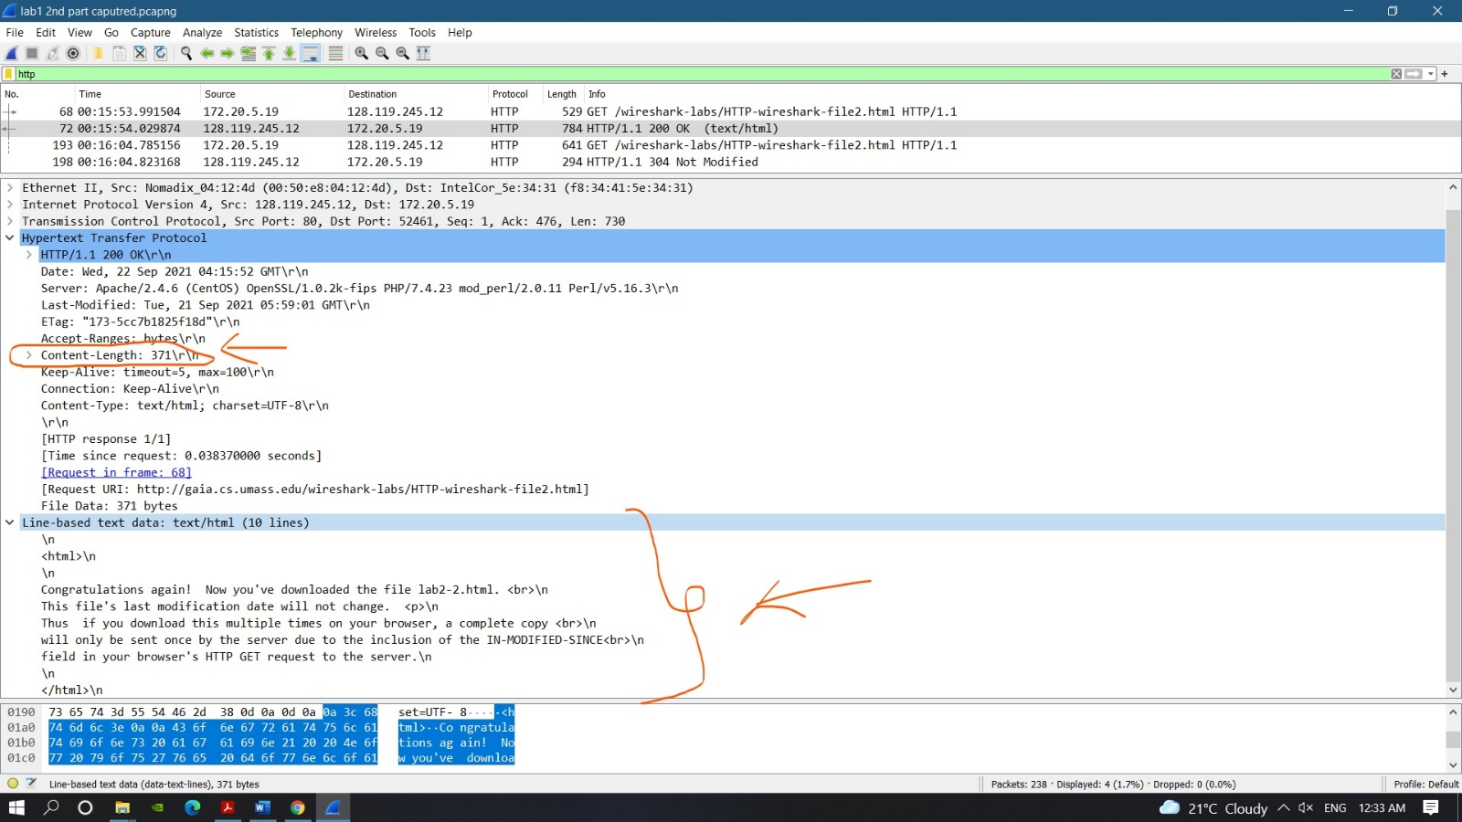

1. **YES,** after inspecting the second HTTP GET request from my browser to the server has an “IF-MODIFIED-SINCE:” line in the HTTP GET. And then the information following the “IF-MODIFIED-SINCE:” is **“If-Modified-Since: Tue, 21 Sep 2021 05:59:01 GMT”**

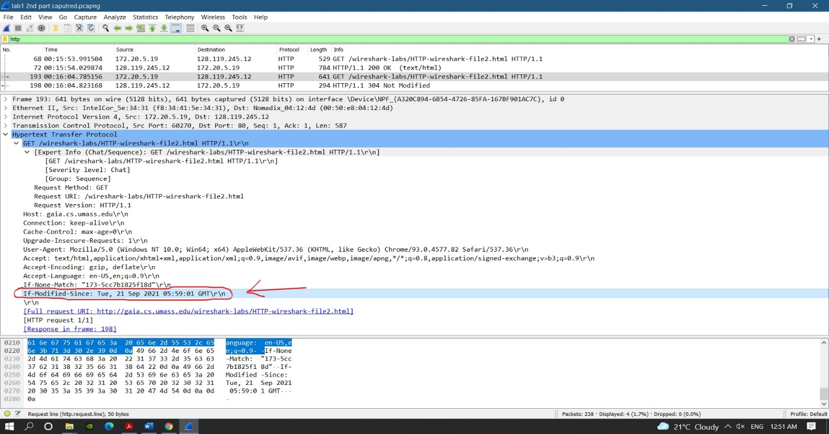

1. In response to the second HTTP GET the “**HTTP status code = 304: Not Modified”** and **HTTP** **phrase returned= Not Modified.**

**No,** the server did not return the contents of the file for second HTTP GET as the requesting IP address and the response IP address is same as the first HTTP GET request so the data/content is already cached (cached memory) or is present to the browser for first HTTP GET response and is not modified.

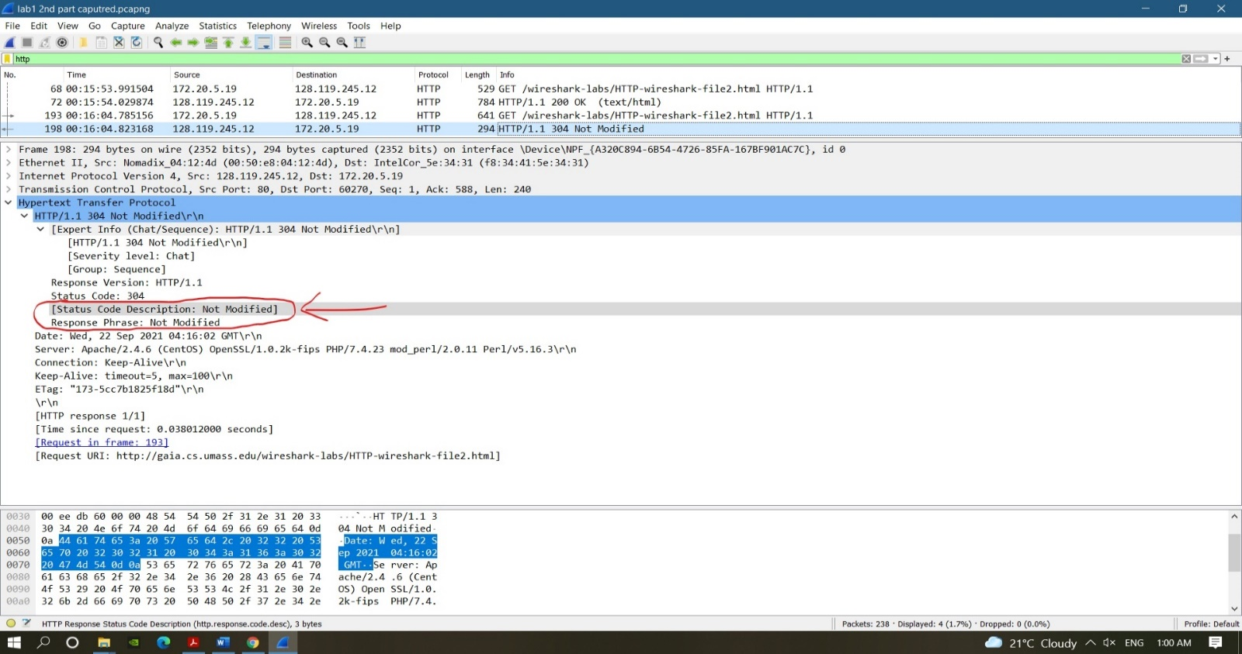

1. **Retrieving Long Documents:**
2. My Browser sent only 1 request i.e., **1 HTTP GET request**.

And the packet number that contain the GET message was **160.**

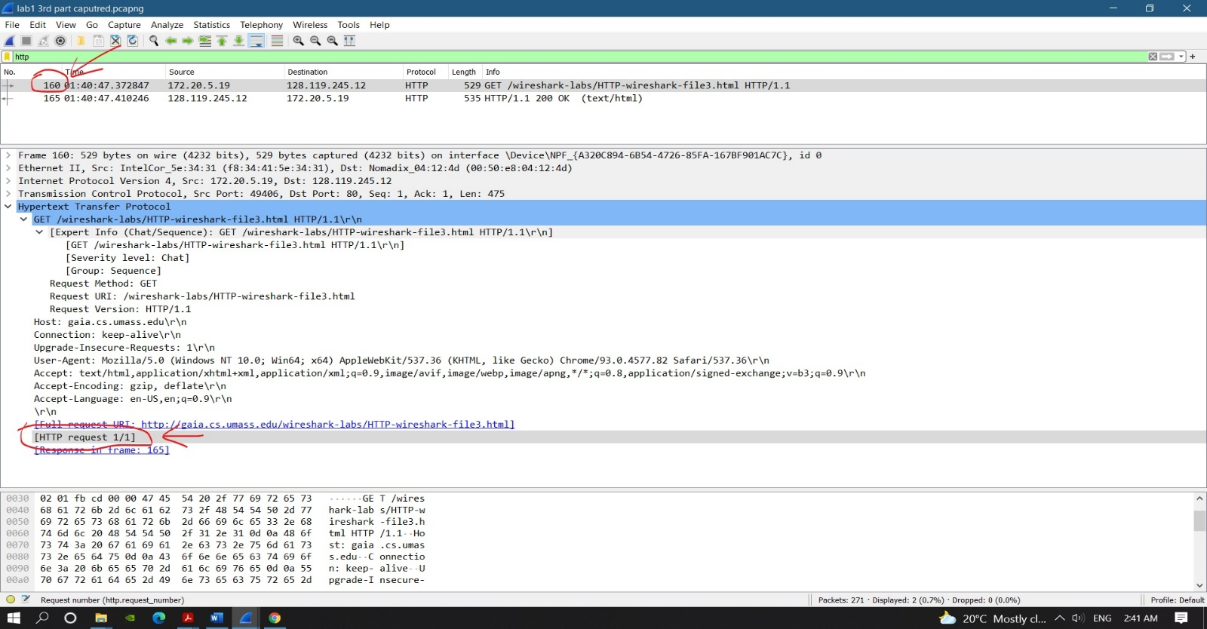

1. The packet number in trace contains the status code and phrase associated with the response to the HTTP GET request is number **165.**

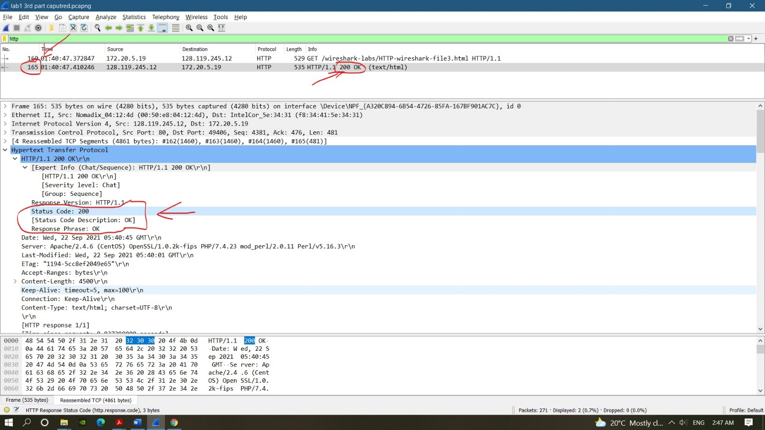

1. The status code was **200** and the phrase in the response was **OK** i.e., 200 OK.

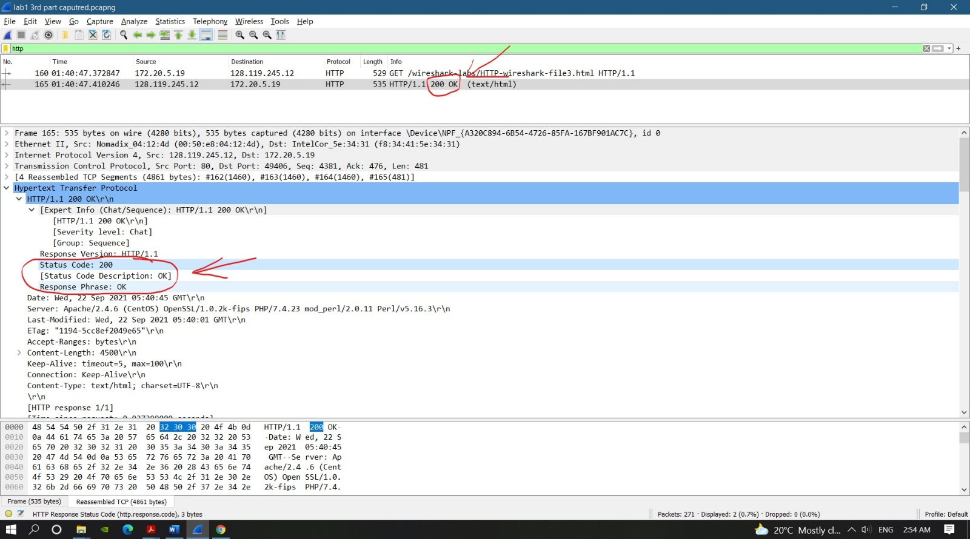

1. Total of **4 data-containing TCP segments** were needed to carry the single HTTP response and the text of the Bill of Rights.

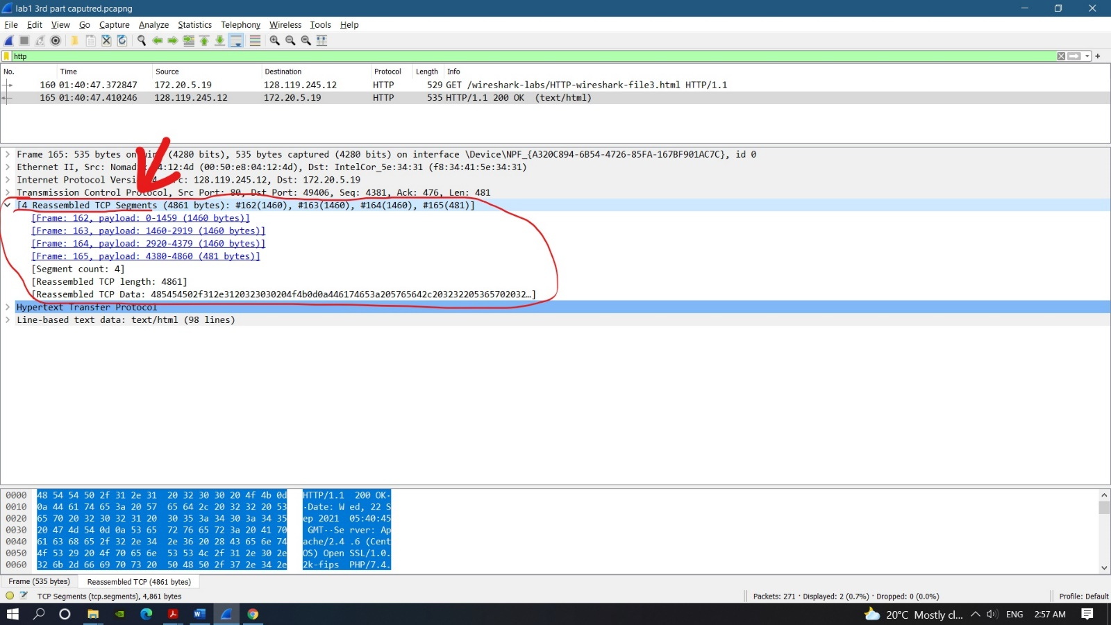

1. **HTML Documents with Embedded Objects:**
2. A total of **3 HTTP GET request messages** were sent by my browser.

And to internet address of:

* Page Address (no.56)- **128.119.245.12**
* Pearson.png logo (no.61)- **128.119.245.12**
* 8E_cover_small.jpg (no.70)- **178.79.137.164**

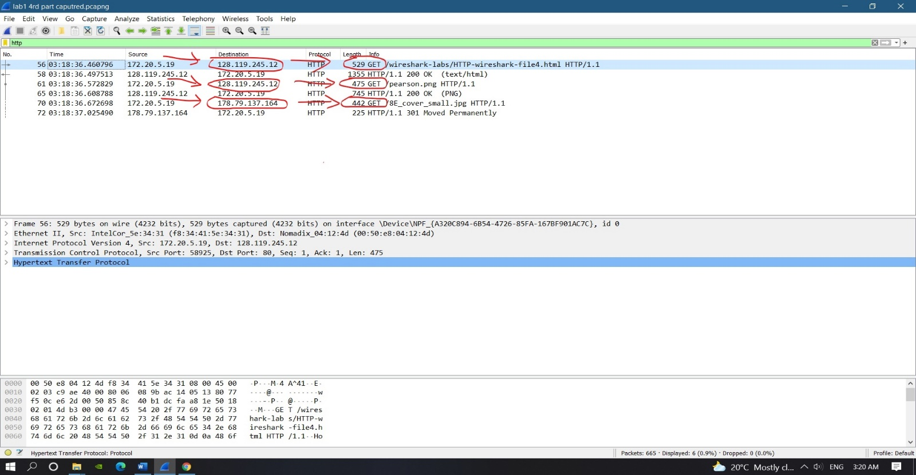

1. In this case I think the browser downloaded the two images **serially,** because the response to each image HTTP GET request is provided as soon as they are being requested or before the second image or the second HTTP GET request. Therefore, the browser downloaded the two images serially as marked in the figure bellow.

